Installation Guide – Ibistic Integration Framework (IntFX)

We are now ready to deploy the Ibistic Integration Framework. This framework allows us to distribute updates to the integration clients remotely and reduces the number of manual tasks to be performed by the client’s IT department. Upon installation of this application, we will send all the necessary parameters to configure the integration client.

This application must be run on a computer (Windows Server 2008 R2 or newer) with Microsoft .Net Framework installed, minimum version 4.5.2. MS .Net Framework is available from Windows Update or direct download from Microsoft:
https://www.microsoft.com/en-us/download/details.aspx?id=48130

Please follow the procedure outlined below.
Running the installation set
Prior to installing this, please make sure that the Microsoft .Net Framework 4.5.2 or newer is installed on the server, and that you have uninstalled the previous version of Ibistic Integration Framework.

Note: The user you run this installation with and install certificate with, should be the same user as the task schedule / integration will run with. This user should have read / write access to the integration folders at all time. Prior to the installation, you also need to provide the Invoice Import folder path and Data Export (ERP Masterdata) folder path to Ibistic.

- Execute the IntFX MSI file you will find attached in the mail received by Ibistic Support. Following screen should appear:
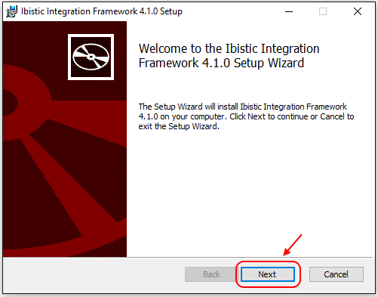

Click “Next”!

- Read and accept End-User License Agreement and click “Next”
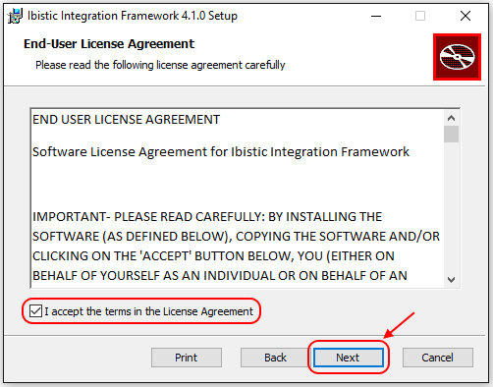

- By selecting Typical Setup type, a default program path will be chosen, IE C:\Ibistic\Ibistic Integration Framework, with standard options. If you wish to select install path, choose “Custom” / Next, otherwise click “Typical” and Next, and skip to step 5.

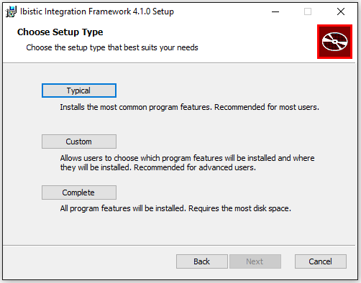

- Screen shown, in Custom Setup. Select folder path to install Ibistic IntFX and click Next:

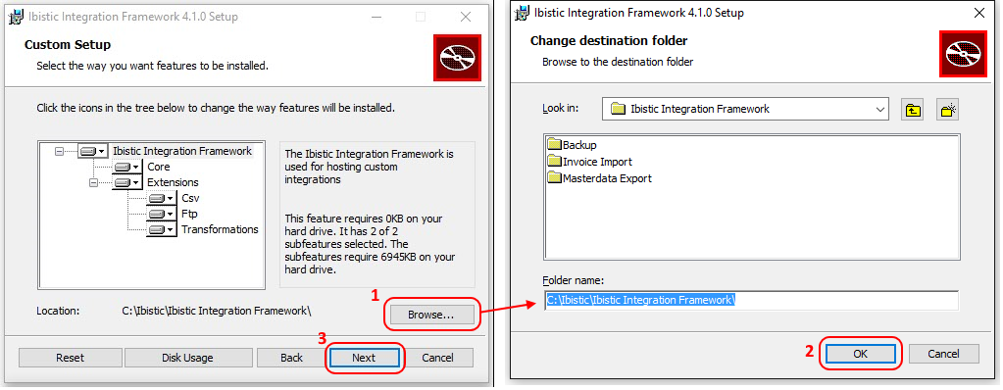

- Click “Install” to start the installation:
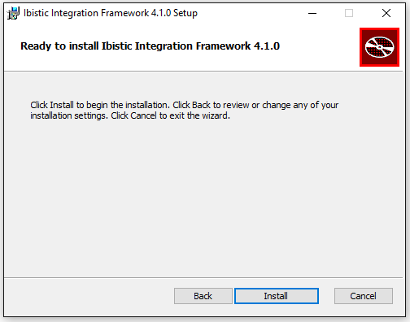

- Once the installer completes unpacking the files, you will be presented with a form requesting a Client Update ID and a certificate file (included with this installation set). You should paste the Client Update ID into the field, and browse to the certificate (“Install Certificate from file”). Once done, click Continue, and you will be prompted with the Certificate Password.

Client Update ID: xxxxxxxx-xxxx-xxxx-xxxx-xxxxxxxxxxxx
Use the certificate you’ll get with this mail, password: xxxxxxxxxxxxxx

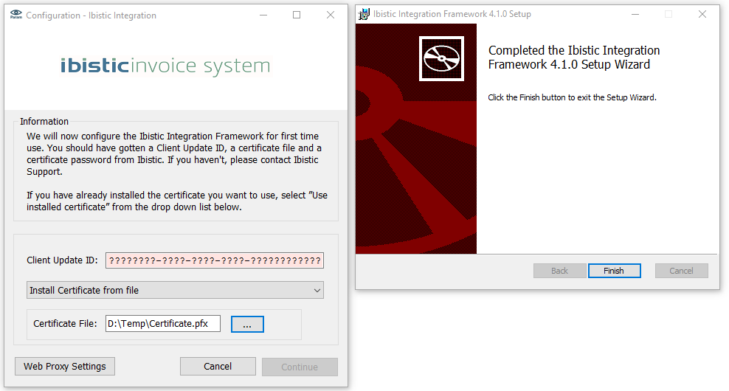

- The Certificate Password is entered in the next screen.

Configuring scheduled tasks
Once installation is done, in order for the integration to run automatically, you will need to manually setup scheduled tasks. If you want to run schedule tasks with another user (not the one who install the application) you must install the certificate for this user and give full control of the Ibistic folder to this new user. As a general rule to avoid problems, task schedule should be set up with the same user as you installed the Integration Framework and certificate with.

- First, start Task Scheduler in Windows:
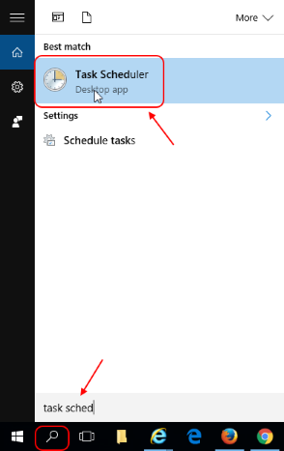

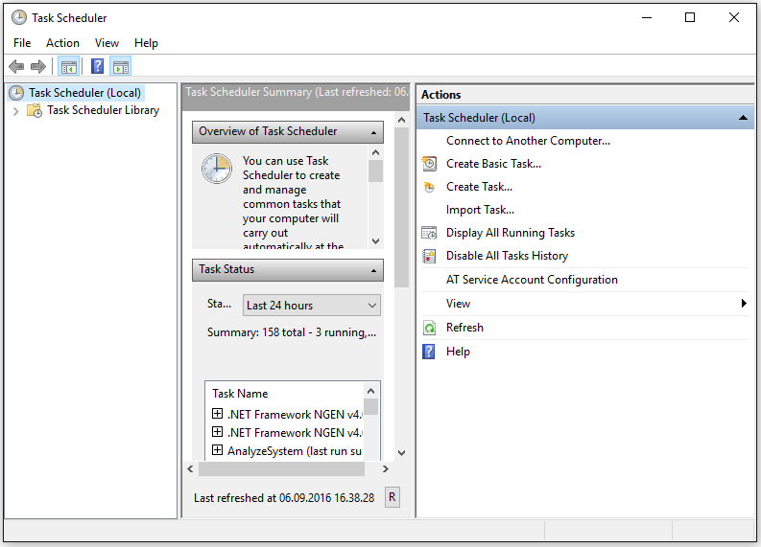

- We recommend creating a folder for Ibistic, since we will be creating 2 tasks, one for Ibistic Chart Export, and one for Ibistic Invoice Import (or “Voucher Import”, if it is both invoice and expense):

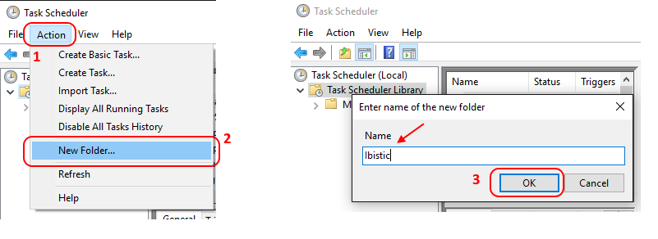

- Next we create the tasks. To create a new task, you select “Action” -> “Create Task”, or simply right click to select “Create New Task”
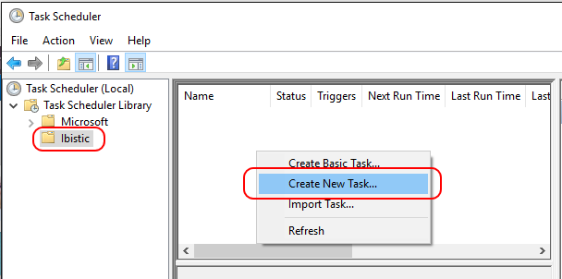

Assuming the framework has been installed into C:\Ibistic\Ibistic Integration Framework, the tasks to be scheduled are as follows (the steps are explained in detail the following pages)

Name: Ibistic ChartExport
Run: "C:\Ibistic\Ibistic Integration Framework\Ibistic.Integration.Host.exe"
Argument: parameters.xml
Start in: C:\Ibistic\Ibistic Integration Framework
Schedule: Every hour, on the hour (i.e. from 0:00 till 23:00)

Name: Ibistic InvoiceImport
Run: "C:\Ibistic\Ibistic Integration Framework\Ibistic.Integration.Host.exe"
Argument: parameters_invoiceimport.xml
Start in: C:\Ibistic\Ibistic Integration Framework
Schedule: 15 minutes past every hour (i.e. from 0:15 till 23:15)
- Creating a new task (step 3), you will be presented with the following screen, we will start creating the task for chart import:
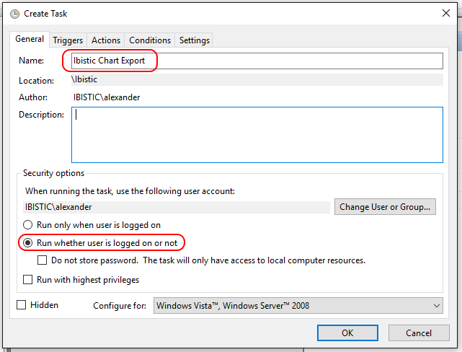
(select task name, and check “Run whether user is logged on or not”)

- We will next create a Trigger how often this task runs:
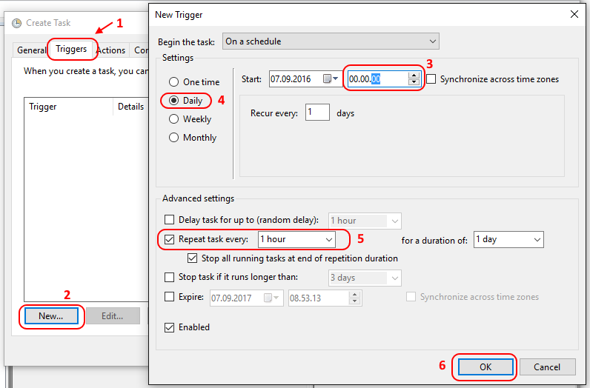
(we recommend setting the task to run every hour)
- Here we specify what Action to be performed when the task is triggered. In this case, we are specifying the Ibistic.Integration.Host.exe file to be run with the parameters.xml argument for Chart Integration (importing masterdata from ERP to Ibistic)

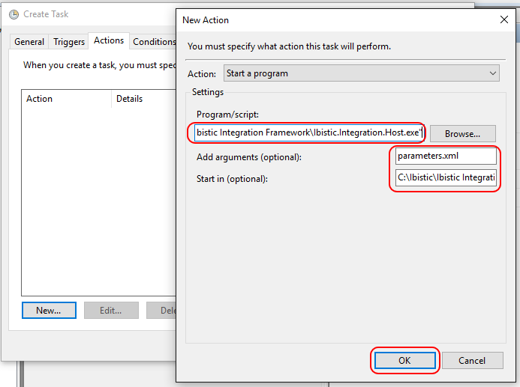
(make sure you navigate to the correct folder paths, screen shows default paths. You should browse / navigate to the Integration.Host.exe file, set parameters.xml as argument, and “Start in” is the folder name where IntFX was installed, for example C:\Ibistic\Ibistic Integration Framework)

- The Conditions should keep default values, so no need to change anything: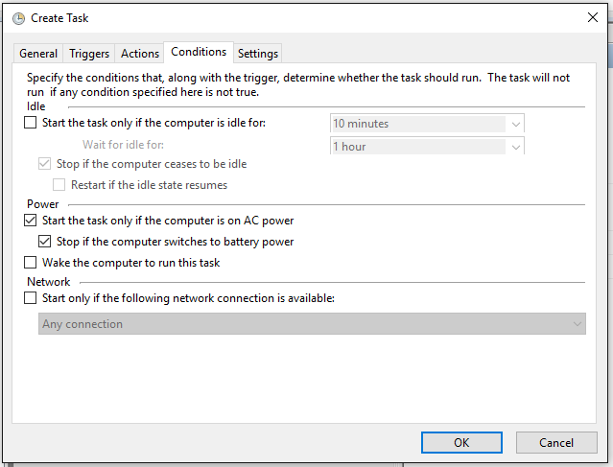

- Settings should also maintain default values
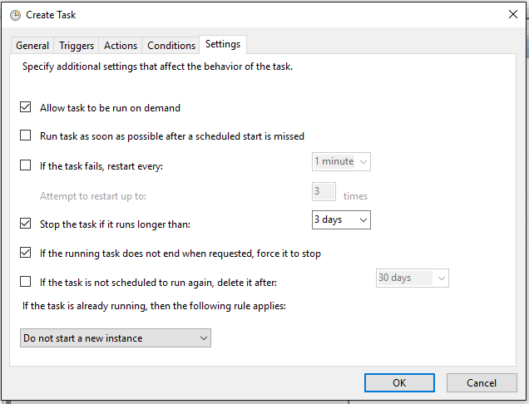

- Once all set, we may click “OK” to confirm creation of the task. Task scheduler will be updated with the tasks you created:

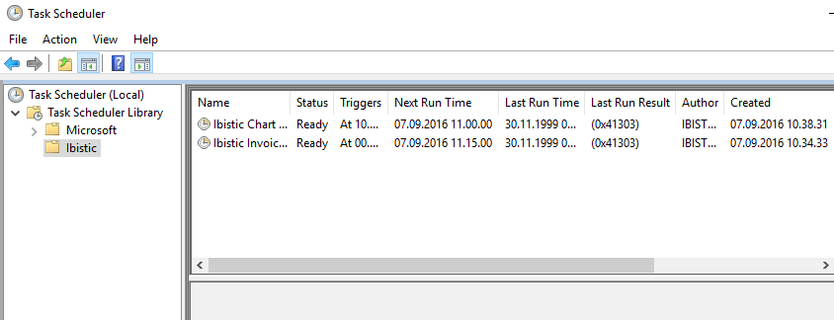

- Invoice Import task is created the same way as Chart Import Task, except for a few minor differences. First the name, “Ibistic Invoice Import”:
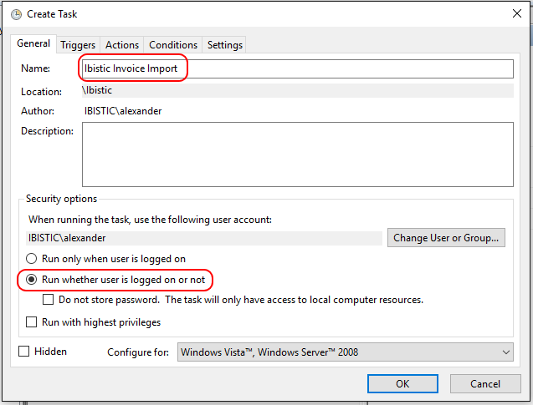

- The trigger, which we in this example set to start 15 minutes past every hour:
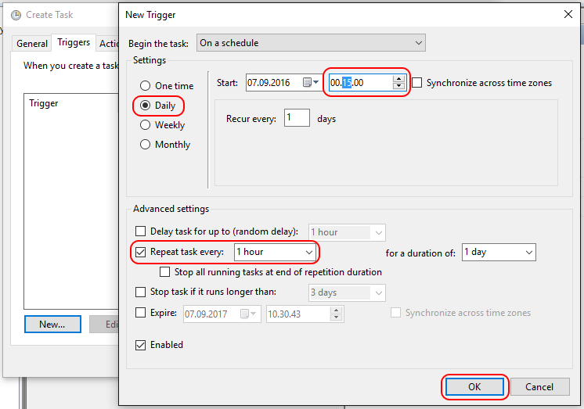

- Finally, and most importantly, we need to set a different argument in the trigger for Invoice, we need to point to the parameters_invoiceimport.xml in “Add arguments”:
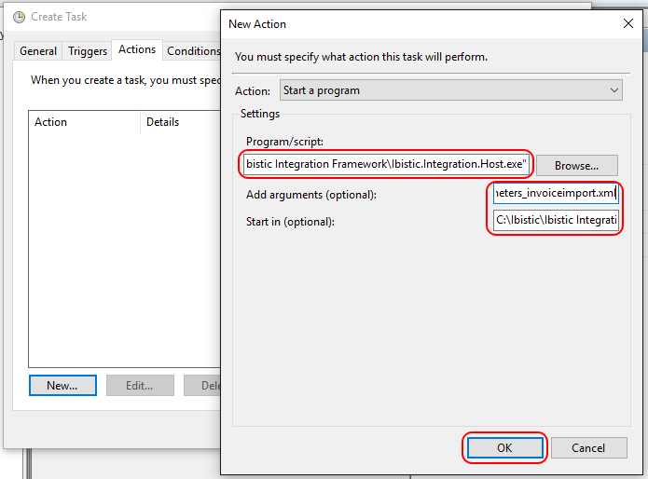

(make sure you navigate to the correct folder paths, screen shows default paths. You should browse / navigate to the Integration.Host.exe file, set parameters_invoiceimport.xml as argument, and “Start in” is the folder name where IntFX was installed, for example C:\Ibistic\Ibistic Integration Framework)

If you have any further doubts about how to create the schedule tasks, please read this how-to (http://support.microsoft.com/kb/308569)

MISC notes for running the integration:
- The schedule will be overridden by the application internally, i.e. the actual chart export and invoice import will be executed less frequently.
- The server clock needs to be kept synchronized. If the time is more than 5 minutes out of sync, Ibistic Integration will not run.
- You may at any moment run the integration manually, by right clicking on the task in task scheduler, and select “Run”.
- After installing Ibistic Integration Framework and once the integration is running successfully, you should follow our recommended Server Guidelines, to prevent any disruptions or downtimes to the integration service.

Troubleshooting
- Please verify folder paths are correct, and that read / write access to the Integration folders is enabled for the Windows user executing the application.
- Make sure the client certificate is installed and running for the user executing the application.
- Check executionlog.txt and error logs in Ibistic Integration folder. Please relay this information to Ibistic (with a copy of the logs) when creating a ticket at support (support@ibistic.com), for quicker resolution and troubleshooting.
- If assistance is required from Ibistic, please have a server administrator available (support needs contact information, phone and email) with a teamviewer session (we will need ID and PW to connect). Teamviewer window should not be minimized during the remote session, otherwise the session will be blocked.

If there are any doubts or questions, please do not hesitate to contact us:
Ibistic Support <support@ibistic.com>

Ibistic Integration Installation Guide V1.2

